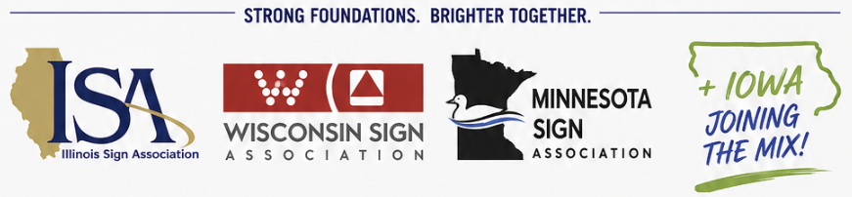

FOR IMMEDIATE RELEASE
Wisconsin, Minnesota and Illinois Sign Associations Approve Merger to Form Great Lakes Sign Association

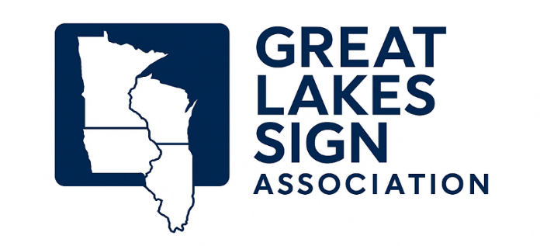
July 1, 2026 — The board of directors of the Minnesota, Wisconsin and Illinois Sign Associations have approved a merger to create the Great Lakes Sign Association (GLSA), a new regional organization dedicated to serving the sign and visual communications industry throughout the Upper Midwest. The organization will remain a local affiliate of the International Sign Association.
Since December 2025, a work group representing each of the three associations has met regularly to develop the framework for the new organization. The group has adopted bylaws, established shared goals and created an organizational structure that reflects the strengths and priorities of all three founding states. As the association begins operations, Iowa will be invited to participate as a member state.
Henry Van de Werken, chair of the merger work group and president of Sign Business Solutions LLC, said, "Discussions about a merger have been ongoing for more than a decade. It is exciting to see that the time was right, and that the leadership of each organization was ready to take this meaningful step forward."
Mission
The mission of the Great Lakes Sign Association is to advance and connect professionals in the sign and visual communications industry across Minnesota, Iowa, Wisconsin and Illinois. By combining resources and expertise, the association will strengthen peer connections, improve operational efficiencies and expand educational, networking and member service opportunities while building on the successes of each founding association.
Deven Ziertman, president of the Minnesota Sign Association, said, "We appreciate that our neighboring sign associations share the vision that this new, expanded regional group will provide greater benefits to a broader group of professionals in the sign industry."
Brian Green, president of the Wisconsin Sign Association and owner of Silver Leaf Signs, said, "The operational efficiencies and valuable improvements created through this collaboration will give more sign shops and suppliers the opportunity to engage, connect and benefit from one another."

Inaugural Annual Convention
A major milestone in the merger is the inaugural Great Lakes Sign Association Fall Education Conference & Expo, scheduled for September 9–10, 2026, at Kalahari Resort & Convention Center in Wisconsin Dells, Wisconsin.
The conference will feature:
- Educational sessions led by industry experts
- Tabletop exhibits and expo opportunities for Industry Partners
- Networking events
- An awards dinner recognizing excellence through a new multi-state Sign Design Awards Program, the Maury Ely Distinguished Service Award, scholarship awards and other industry honors

New Association Logo
To celebrate the launch of the organization, GLSA will hold a logo design contest. The contest is intended to engage members and create a distinctive visual identity for the association.

Governance
The Great Lakes Sign Association will be governed by a Board of Directors. Three State Councils representing Illinois, Minnesota and Wisconsin will be established, with each council electing three representatives to serve on the GLSA Board.
The Board of Directors will oversee:
- The Annual Convention and Trade Show
- The Great Lakes Sign Association Scholarship Program
- Marketing and communications
- The online membership directory
- Relationships with state, regional, national and international industry organizations
- Educational and workforce development programs
- Support for State Councils
- Financial management and accounting
- Contracted association management services, including Executive Director services

Standing Committees The association will establish the following standing committees:
- Conference & Expo Planning Committee
- Sign Design Awards Program Subcommittee
- Scholarship Committee (college, trade school and continuing education)
- Fundraising Committee
- Maury Ely Distinguished Service Award Committee
- Industry Partner Program Committee
- Marketing, Communications and Member Engagement Committee
- Membership Recruitment Committee
- Online Education and Training Committee

Work Group Members
The GLSA Work Group includes:
- Deven Ziertman, Ziertman Sales Consulting LLC
- Brian Green, Silver Leaf Signs
- Kelsy Wedelstadt, Creative Sign Company
- Krista Suhr, Jones Sign
- Brian Meyer, Creative Sign Company
- Henry Van de Werken, Sign Business Solutions LLC
- Andrew Carby, Prairie Signs Inc.
- Craig Gray, Wensco
- Jim Murphy, Mid-West Sign Supply
- Brian Newton, Parvin Clauss Sign Company
- Brandon Bender, Electro-Matic
- Tina Conley, Wisconsin Sign Association
- Patti King, Minnesota Sign Association
- Russ Salzman, Illinois Sign Association

Media Contacts
Henry Van de Werken
2026 President, Illinois Sign Association
Chair, Great Lakes Sign Association Work Group
President, Sign Business Solutions LLC
henry@signbusinesssolutions.com
Russ Salzman
Executive Director, Illinois Sign Association
Facilitator, Great Lakes Sign Association Work Group
rsalzman@isa-sign.com

